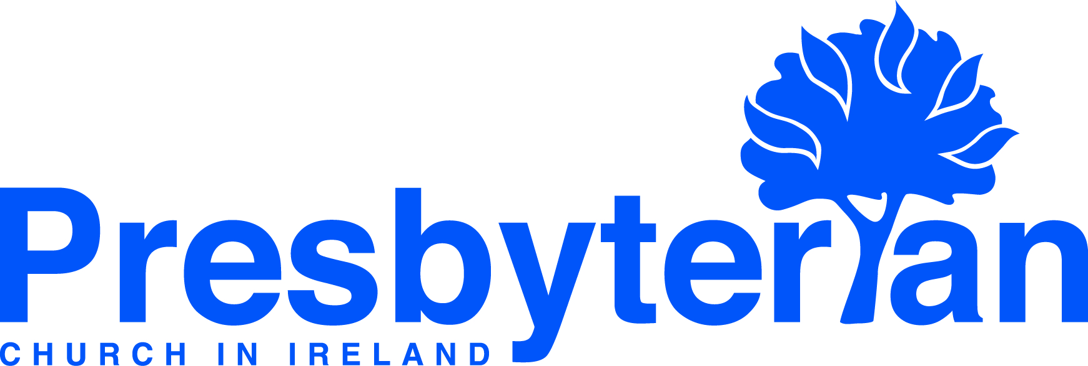
Let’s Pray | Sun 18 October - Sat 24 October 2026
Friday 23 October
- General Council | Pray for the meeting of the Linkage Commission taking place this incoming week – convener, Rev Ker Graham and secretary,
Mr Kenny Belshaw. Pray that good decisions will be arrived at which will be to the long-term benefit of PCI, especially against the backdrop of the
ongoing process of reconfiguration.
- Training in Ministry | Pray for church planting seminars being held in conjunction with CMI this month for licentiates, students, and anyone else
who is interested in this important aspect of church life. Pray for Dan Steel, Principal and Ministry Coordinator of Lanier Theological Library and Learning Centre, Yarnton Manor, Oxford and author of 'Wise Church Planting', who spoke this week.
Thursday 22 October
- Galway, Rev Helen Freeburn | Pray for considerations of a building project to renovate our facilities to provide accessible toilets, meeting
rooms and a welcome space. As we step forward with faith, pray for vision, finances and the Lord's guidance. Pray also for student, youth and
children's ministries, giving thanks for new students and their great leaders, praying for more helpers in this area. Pray for the elders and committee members during a busy season in church life and for the Lord to send more labourers into his harvest field.
- Rev Colin Dickson, International Meeting Point (IMP) | He answered, “‘Love the Lord your God with all your heart and with all your soul and with all your strength and with all your mind’; and, ‘Love your neighbour as yourself.’” Ummah (Arabic word for community) is so important for people coming from Africa, Asia and the Middle East. Pray for staff and volunteers as they ‘seek to grow a sense of community’ (Luke 10:27 above), which is one of IMP’s core values, in both centres and the Op Shop.
Wednesday 21 October
- Naomi Keefe, global mission worker, Brazil | Give thanks that Naomi has arrived back safely in Brazil after being on home assignment over the summer months. Continue to pray for the preparation of materials for the ‘Coffee with God’ Bible studies with a view to the possibility of doing something similar in Beberibe. Pray also for the ‘Reading in the Park’ every Tuesday, especially that the team will use this opportunity wisely to witness to others about the good news of Jesus. Pray for God’s watchful care and protection over all who organise and participate in these gatherings.
- United Mission to Nepal (UMN) | UMN ask that we continue to pray for the co-ordination and timely delivery of aid to the vulnerable, flood-affected households in urgent need, many having lost their homes, livelihoods and access to basic services. Making such provision requires the restoration of access to some communities that remain cut off by damaged roads and bridges. Pray also for the Nepali Government’s recovery planning processes including decisions related to the relocation and resettlement of those worst affected.
Saturday 24 October
- Council for Public Affairs (CPA) | As they prepare to meet in the coming weeks, please pray for the committees, panels and task groups within
the Council for Public Affairs. Pray for their conveners and members, that they will be able to discern God’s leading regarding their topics and subjects,
so that they will engage effectively and speak Christian truths confidently and graciously into the public square.
- Carlisle House | We thank you for Carlisle House residential treatment centre as it offers support to adults facing challenges with substance
misuse. Bless this place with kindness, purpose and hope. Strengthen those who serve others here, guide their decisions, and help them make a positive
difference in the lives of those they meet. May Carlisle House be a place of welcome, compassion and community.
Tuesday 20 October
- Arklow, Rev Michael Anderson | Give thanks for a wonderful holiday club and the 23 leaders from the church who helped. Give thanks also
for a successful Bake-Off Youth night and pray that all who could will come to the next event planned for October. Thank God for a successful liver transplant for one of our members and pray for their full recovery.
- Claire Sellar, healthcare chaplain, Ulster Hospital | Pray for Claire and her chaplaincy colleagues, that they would be blessed in this work and would be a blessing to those they come into contact with.
Monday 19 October
- Derek and Jane French, global mission workers, Spain | Praise God for the student welcome service that took place on 11 October and pray that those who attended would feel part of the Bilbao International Church family. Give thanks also for the recent GBU students’ camp, praying that those who attended would be ignited with a passion to share the gospel with others.
- Wycliffe Bible Translators (WBT) | Pray for the work of Bible translation worldwide aiming that one day everyone will have the Bible in their own language. Pray especially for the funding and delivery of accredited training in Bible translation at the Theological College of Northern Nigeria in Jos, that gifted young men and women can be equipped to be effective Bible translators, well placed to unlock God’s Word for the 64 communities in Nigeria still waiting for Bible translation to start in their language.
Sunday 18 October
- Moderator | Pray for the Moderator as he leads the morning service at Cloughwater Presbyterian Church – minister, Rev Alistair McCracken. Give
thanks for the life and witness of the congregation and pray that they might know God’s blessing and guidance in the years ahead.
- Worship: Listen to God | Today if you hear his voice, do not harden your hearts. Psalm 95:8. Give thanks for how God speaks in worship and ask
that he might give you a receptive heart to what he wants to say to you.

