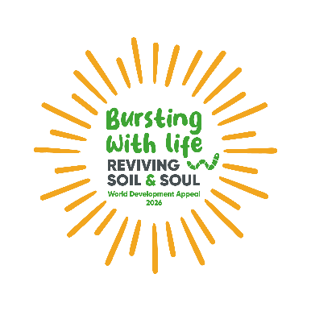


Project Impact Reports


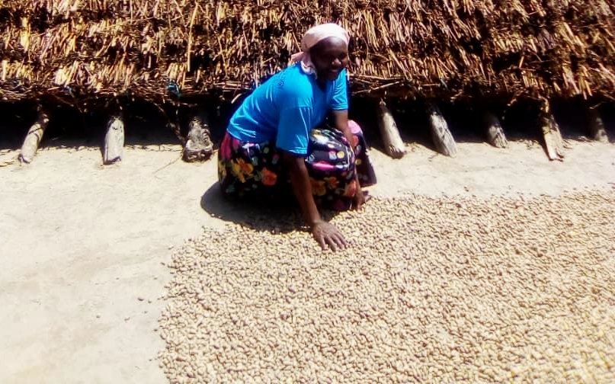
Anna Akao lives in Ipenet village, Bululu. She is a farmer but poor yields meant that the enterprise only offered her family a poor standard of living. But after receiving training from Tearfund’s partner, in two years, her harvest increased six times over. She is now saving about £10 a month and plans to irrigate her land, enabling her to grow high-value crops. She is pictured above with her harvest of groundnuts. Source: CoU-TEDDO/ Tearfund
Thank you
Thank you for the committed partnership of the Presbyterian Church in Ireland through the 2024 World Development Appeal. The projects you have supported have made a material and lasting impact on lives, families and communities around the world: reducing food insecurity, increasing resilience. At the heart of many of these projects is the local church, acting with vision and passion to transform the lives of the people around them.
Rwanda - £62, 140 | Malawi - £24, 222
Burkina Faso - £59, 177 | Uganda - £13, 111
Bangladesh - £37, 155 | Iraq - £4, 937

Rwanda

This is an amazing project transforming the economic livelihoods of thousands of rural Rwandan families.
Ten thousand rural farmers, joined together in 500 ‘Self-Help groups’, have been training in more effective farming techniques, as well as post-harvest techniques which increase the value of their crop. This includes training on crop diversification, organic fertiliser, soil fertility, seed propagation, and harvest management. It also includes value-added agriculture, supporting farmers to improve production processes and identify commercial farming opportunities, increasing the economic value of their farming through particular production processes. Low-cost post-harvest and irrigation facilities will be established to improve agricultural production and climate resilience.

The total savings of these groups increased by 48% - meaning more resilience for crises, better access to healthcare and education, and a sustainable escape from extreme poverty. The groups themselves become little circles of support - emotional, practical and spiritual - as people build community together.
Burkina Faso

In Burkina Faso, 86 per cent of the population relies on subsistence agriculture to provide for their basic food needs. This project, with our local partner Office de Développement des Églises Évangéliques (ODE), has reduced food insecurity in agricultural communities. The focus has been to provide training in sustainable agriculture, financial management and Self Help Groups.

A total of 21 churches took part in training to run their own Self-Help groups in and around their congregations. 42 groups have been established, attended by 1030 people. These groups are now in their second and third round of savings which has had a transformative effect on the lives of the families represented. The impact on women is particularly significant, as they are now able to contribute to the financial wellbeing of their families and their community.

1,428 people in 30 farming cooperatives received training and resources to improve their farming practices. In particular, they were shown how to run their own market gardens. They took part in training to help them create their own compost and liquid fertiliser made from natural materials. Farming cooperatives were trained in how to harvest and store many vegetables and crops, such as onions and rice.
Bangladesh

In the Patuakhali district of Bangladesh by the Bay of Bengal, communities are facing immense suffering due to regular flooding, salinization of soil and water, and unpredictable extreme weather. This is destroying crops and livelihoods, pushing people into poverty, and leading to rises in gender-based violence and child marriage.

To address this crisis, Tearfund is working through local churches with our partner, World Concern Bangladesh (WCB), in 50 of the most vulnerable communities. Over three years, the project has been aiming to increase resilience to climate disasters, prevent gender-based violence, and improve economic stability.
This project has seen communities work together to prepare for disasters, through early warning systems, emergency drills and training of church-based rescue teams. At this stage, 74% of communities say they are better equipped to weather these crises.

The project has substantially improved economic well-being among the target population. At baseline, only 7% of community members reported satisfaction with their economic situation, reflecting widespread financial insecurity and limited livelihood opportunities. By endline, satisfaction levels soared to 94%, demonstrating significant progress in income diversification, access to livelihood support, and adoption of climate-smart agricultural practices. This dramatic increase highlights the project’s success in enhancing economic resilience, empowering households to generate sustainable incomes, and improving overall quality of life.

The project has also driven a profound cultural transformation regarding gender-based violence within the target communities. At baseline, 77% of community members considered GBV acceptable, reflecting deeply entrenched harmful social norms. By the end of the project, this figure had drastically decreased to 7.5%, signaling a major shift in awareness and attitudes.
Malawi

Deforestation rates in Malawi are extremely high, estimated at 33,000 hectares lost per year, which is ruining crops and agriculture - the main income source for most Malawians. Climate change is also bringing erratic rainfall, floods, and droughts which are devastating harvests and food security for farming families in the region.

To address these interconnected issues and break the cycle of poverty, hunger and environmental damage in Balaka district, Tearfund is implementing this project with local partner Eagles. This project is working through local churches and empowering farming communities.

300 Lead Farmers have been identified and trained to lead by example in the wider community. Self help groups have been established and trained on everything from bee-keeping to livestock management. Village Management Committees have been established to conserve and protect local natural resources for the benefit of the whole community.

Our local partner, Eagles, has trained and equipped churches. It has then leveraged the influence and reach of local congregations to engage farmers in the most isolated and vulnerable communities.
With your support in Malawi, the cycle of poverty, hunger and environmental damage in Balaka district is being broken by local churches. That means improved lives, food security and sustainability for farming families facing poverty and hunger.

Uganda

The Teso region of Uganda has high poverty rates, with nearly half the population living below the poverty line. Subsistence farmers are struggling with erratic rainfall, rising temperatures, and declining harvests due to climate change impacts on agriculture.
Tearfund and our partner Church of Uganda Teso Dioceses Planning and Development Office (CoU-TEDDO) are implementing a three-year project in response. This will improve livelihoods and build resilience to climate change for smallholder farmers in the Teso region of northeast Uganda.
Farmers have received training on bio-intensive farming and ecological land management, enabling them to grow enough food to feed their families and sell surplus produce. A model farm has been established to demonstrate effective practices to local communities. When farmers gather in cooperatives, they can gain access to improved seeds, dehydrators, cash-safe boxes, subsidised tricycles.

Gender equity and equality in land tenure, access and control are essential to improve food security, education, health and economic development. Training has been delivered to help communities analyse their livelihoods from a gender perspective and take practical steps to address inequalities. They will raise awareness of the benefits of women's economic empowerment, challenging social norms and attitudes that hinder women from engaging in economic activities, controlling incomes or owning property and assets.

This has been delivered in a rich partnership with local churches across three parish areas. The churches receive training in the core elements of ‘Church and Community Transformation’ - allowing them to take the lead in delivering and maximising the support provided by Tearfund and our partners.

Iraq

This project, in partnership with a range of other local and regional organisations, has focussed on supporting communities in Ninewa and the Thiqar Marshlands recover from conflict and build resilience in the face of two significant challenges: water scarcity and continued social instability. In a challenging local environment and a region facing significant challenges, this project is seeing a new generation of leaders trained to protect and conserve vital water resources, in partnership with others in their local communities.

Crucially, the initiative trains and empowers a new generation of local leaders, specifically targeting youth and women, to protect vital water resources, secure agricultural livelihoods, and drive sustainable, community-led peacebuilding efforts."


Honduras Project Report

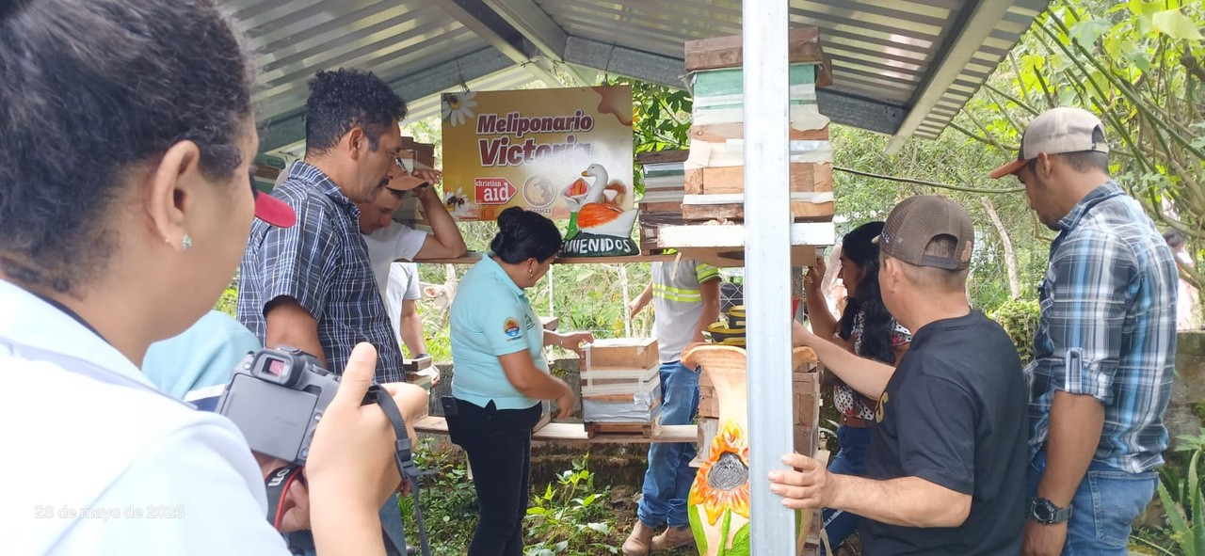
Country | Honduras (Lepaera, Gracias, Belén, La Campa and San Manuel Colohete)
Partner Organisation | OCDIH
Project period | 2025-2027
Reporting period | 2026 (95% of the funds provided by the Presbyterian Church had been spent as of 30 May 2026)

Project Aim

The ProCLIMA II project, delivered with OCDIH across six municipalities, helps rural families strengthen climate resilience, food security and incomes through climate-smart agriculture, crop diversification, improved market access and women-led enterprise.
Thanks to your support, rural families are strengthening their productive diversification and "ability to access markets and sell their products
Key achievements to date

- Families adopted agroecological practices, including crop diversification and agroforestry; two rainwater harvesting and irrigation systems and two solar dryers were introduced.
- Fifty-three people were trained in crop nutrition and farm-strengthening plans, while local organisations improved market access and helped participating families increase income by 15%.
Sierra Leone Reporting Updates

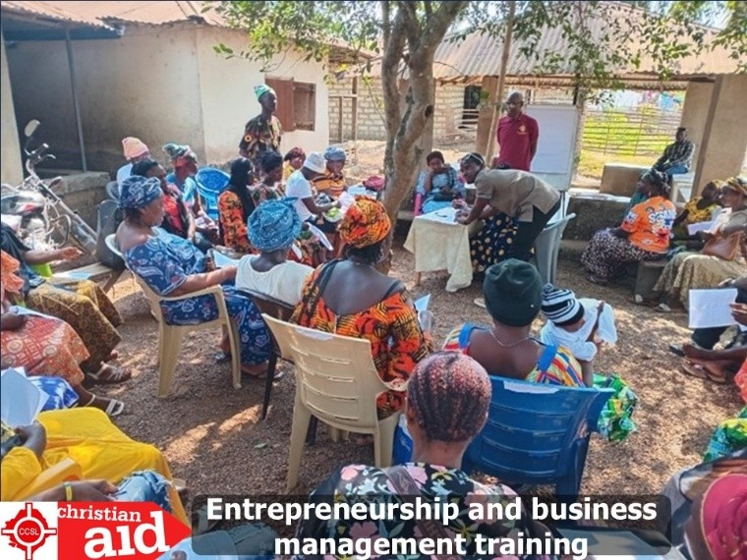

Country | Pujehun District, Southern Sierra Leone
Partner Organisation | Council of Churches in Sierra Leone

Project Aim

Delivered with the Council of Churches in Sierra Leone, the project supported displaced women and vulnerable families across Malen, Kabonde and Kpanga-Krim Chiefdoms through savings groups, climate-smart livelihoods, peacebuilding and access to essential services.
Thanks to your support, vulnerable displaced women and their families in Malen, Kabonde and Kpanga-Krim Chiefdoms have improved their livelihoods, strengthened their resilience, and contributed to stronger, more peaceful communities.
Key achievements

- Reach: 320 people (290 women and 30 men) participated directly, with a further 1,400 community members benefiting indirectly.
- Economic resilience: Ten Village Savings and Loan Associations served 300 displaced women; 80% accessed savings and loans, 45% expanded or diversified their livelihoods, and business performance and income increased by 60% following training and support.
Peacebuilding & Community support

- Community resilience: Women’s farming groups received agricultural inputs, participation in household decision-making increased, and community safety nets supported vulnerable households during illness, emergencies and financial hardship.
Challenges

Challenges included high demand for savings groups, limited farming land, poor rainy-season roads, and insufficient business capital. Regular monitoring and community engagement helped keep delivery on track.
Accountability and Transparency and Inclusion

Safeguarding, monitoring visits, community meetings and feedback channels support transparent, inclusive, and responsive delivery.
Lessons Learned

Key learning was that collective savings and peer support strengthen women’s businesses, while sustainable empowerment works best when finance is combined with mentoring, market links, peacebuilding and psychosocial support.
Words from the Community

“I thank God and CCSL, First Fruit and Christian Aid for helping us regain our pride and dignity. Through the VSLA, my children are back in school, provide clothing my children during special holidays like Eid and Christmas, put food on my table and I can now support my family with confidence.”

Mrs. Baindu Kieh, Chairlady of the Gbotima Women’s Group in Bamba

Through this project, women have strengthened their livelihoods, increased household income, gained confidence and built stronger support networks within their communities.

Burkina Faso Final Project Report
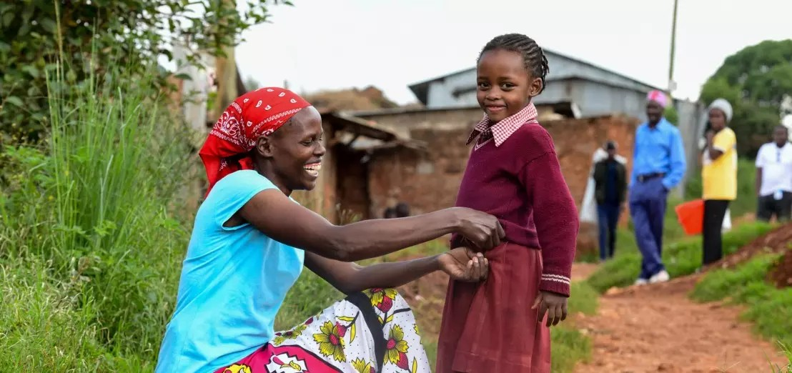
Country | Gourcy Commune, Zondoma Province, Yaadga Region (formerly Northern Region), Burkina Faso
Partner Organisation | Office de Devéloppement des Eglises Evangéliques (ODE)
Project period | 2025-2026
Reporting period | 16 June 2025, to 30 May 2026

Project Aim

Delivered with ODE in response to displacement and insecurity, the project combined emergency food assistance with agricultural and poultry support to help vulnerable households rebuild livelihoods, improve food security and strengthen community resilience.
Thanks to your support, vulnerable households were able to improve their living conditions, rebuild livelihoods and strengthen community resilience. Additional funding allowed the project to expand its reach and support even more families.
Key achievements

- Reach: 2,475 people benefited, including 375 direct and 2,100 indirect beneficiaries, with women forming the largest group.
- Immediate support: 150 vulnerable households received rice, cowpeas, maize and oil during the lean season.
- Recovery: 100 farmers received seeds and vegetable-growing training, while 125 beneficiaries received poultry starter flocks, coop materials and animal-health training.
Combining emergency support with livelihood activities improved food security and incomes and reduced tensions over scarce resources. Regular monitoring, community feedback and technical support strengthened delivery; beneficiary satisfaction was 92%.

DRC Final Project Report
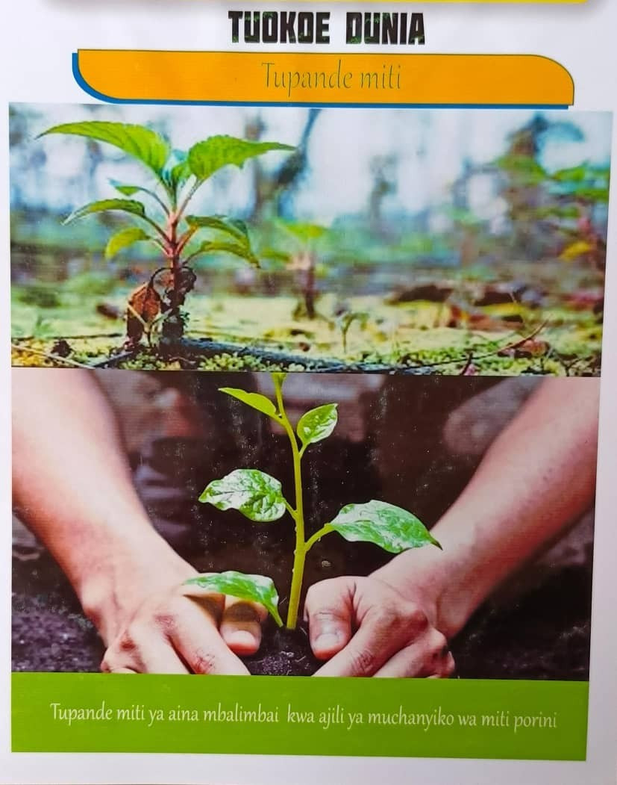
Country | Democratic Republic of the Congo (Mukwija)
Partner Organisation | Eglise du Christ au Congo Sud Kivu (ECC MERU)
Project period | May – October 2026
Reporting period | Final report

Project Aim

Delivered with ECC MERU, the project supports 100 vulnerable displaced households and host communities in Mukwija through cash assistance, climate-resilient agriculture, tree planting and community awareness.
Thanks to your support, people living in Mukwija are benefiting from activities designed to strengthen resilience to climate change and improve their ability to cope with ongoing crises. Your funding has helped expand both humanitarian assistance and climate adaptation activities within the community.
Key achievements

- Humanitarian assistance: 100 internally displaced people (29 men and 71 women), including eight people living with disabilities, received cash support.
- Climate resilience: 100 host-community members were targeted for climate-resilient seeds, and a community nursery was established with eucalyptus, grevillea, orange and palm trees.
- Awareness: 125 local leaders were trained and 516 people, including 61 people living with disabilities, joined climate-awareness activities supported by radio and Swahili information materials.

